SIMPLE PASSWORD STRENGTH CHECKER
Sridevi Dharshini. K(20uad025), Sivaranjani. M(20uad030) , Dharshini.S(20uad041)
Third Year , Artificial Intelligence And Data Science.
Kamaraj College of Engineering and Technology, Virudhunagar.

Objective:
- To implement password checker using java.
- To estimate the password is strong or not.
Abstract:
Passwords are as yet the prevailing path for user verification and system security while other validation techniques exist. So selecting a strong password is a challenging thing. Passwords are used in every walk of life like logging into a system, creating an account in an online store, banking, etc. Passwords with less correlation of private details are the safest to use.
Innovation :
The Stronger the password , the more protected the computer will be from hackers and malicious software.
Methodology Diagram:
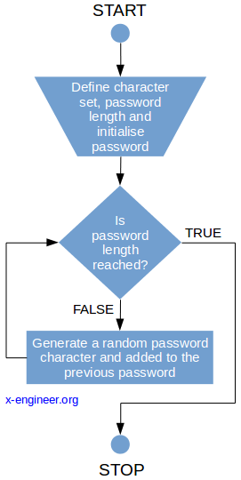
Working Principle:
- Strength meters can only then provide reasonable guidance when they are accurate, that is their score correctly reflect password strength
Screenshots:
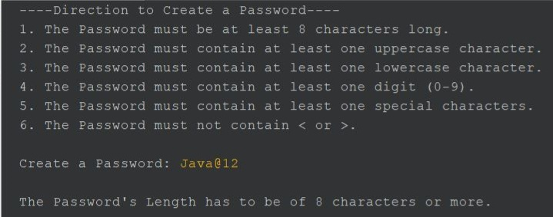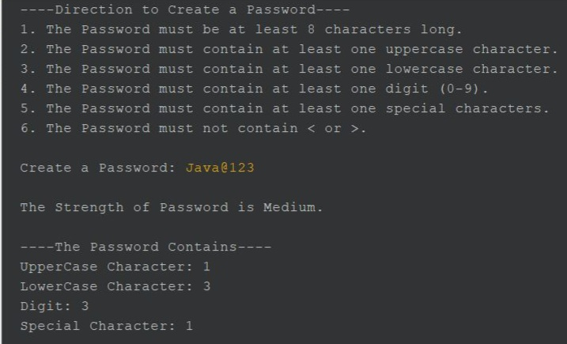

System Requirements:
S/W requirements:
- Java Version 3.5
Outcomes Achieved:
  - Password can be strengthen to secure the data.
  - Weak passwords can be identified during generation.
  - Upcoming applications can use this to warn the user.

Application Areas:
- It is used in areas where security credentials are required which can prevent spoofing of data.
- Also in areas where strong passwords are required because stronger the password more secure is your account.

Conclusion:
By using this project we should maintain strong passwords for all accounts on your computer

